ultramirinc.champs_mood.fragments

Class FriendsFragment

java.lang.Object

android.support.v4.app.Fragment ultramirinc.champs_mood.fragments.FriendsFragment

All Implemented Interfaces:

android.content.ComponentCallbacks, android.view.View.OnCreateContextMenuListener



public class FriendsFragment

extends android.support.v4.app.Fragment

Created by Etienne Berube on 2017­03­23. This class gives a visual interpretation of the friend list of the user. The friends are fetched from the Database and transformed into visual elements. This list is given as a tab for TabActivity

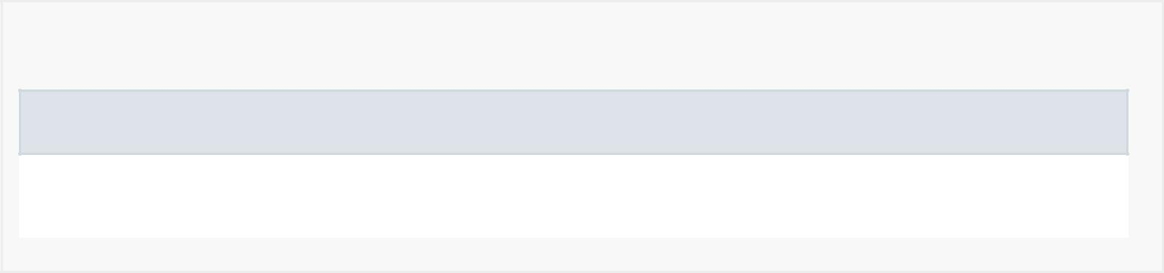

*Nested Class Summary*

Nested classes/interfaces inherited from class android.support.v4.app.Fragment

android.support.v4.app.Fragment.InstantiationException,

android.support.v4.app.Fragment.SavedState

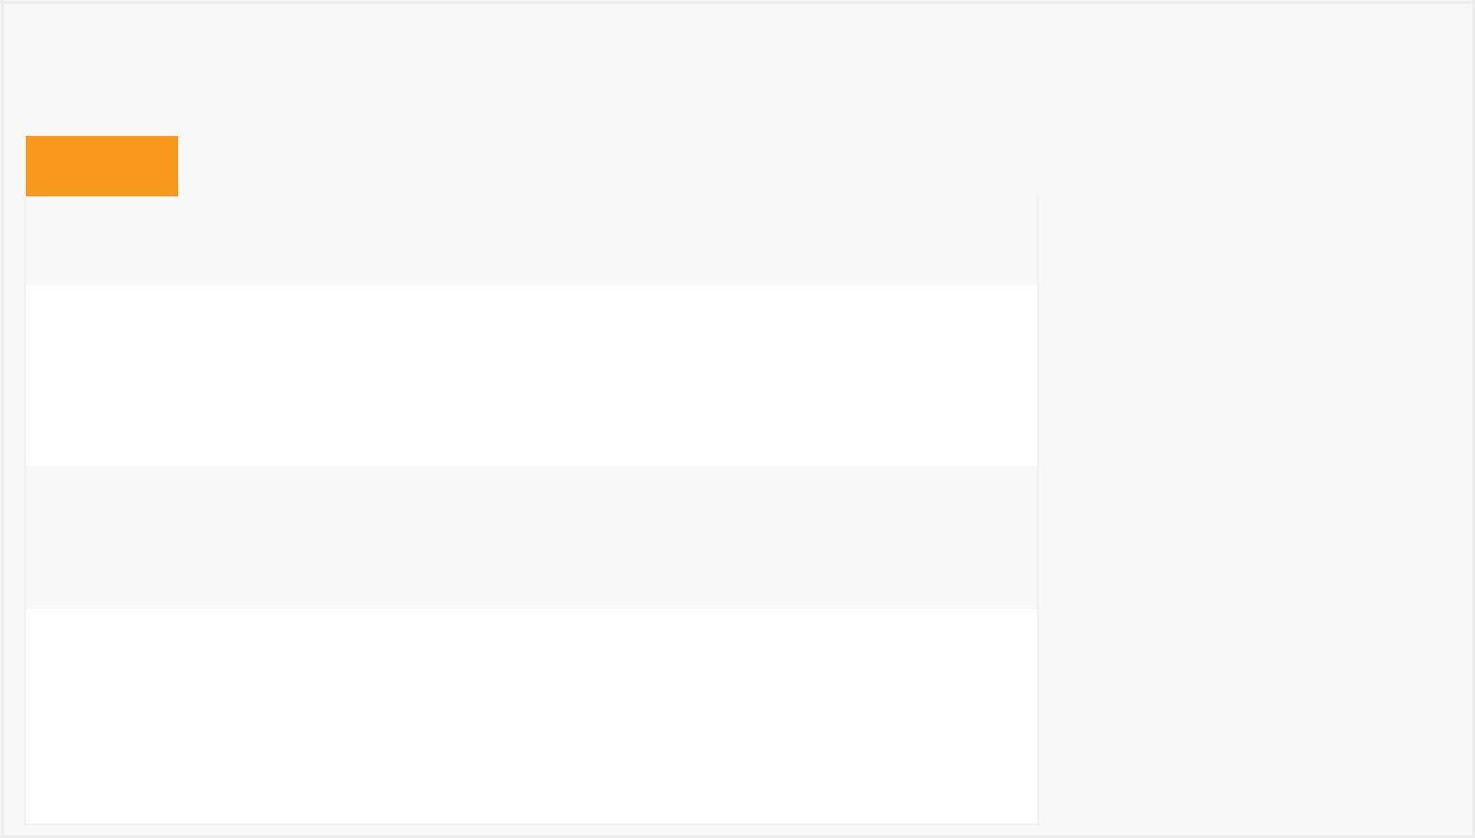

*Field Summary*

Fields

|  |  |
| --- | --- |
| Modifier and Type | Field and |
|  | Description |
| private android.content.Context | context |
|  | Context from |
|  | the attached |
|  | activity |
|  |  |
| private java.util.List<User> | friends |
|  | Contains the |
|  | user's friends |
|  |  |

private android.support.v7.widget.RecyclerView recyclerView

Contains the RecyclerView from the visual layout



*Constructor Summary*

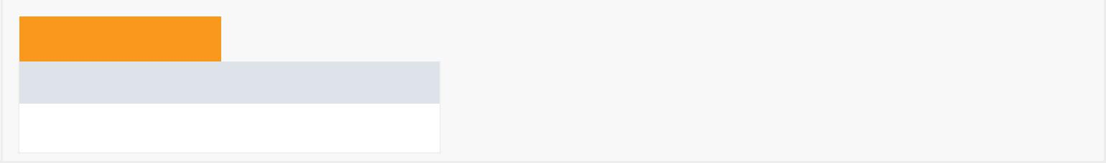Constructors

Constructor and Description

FriendsFragment()

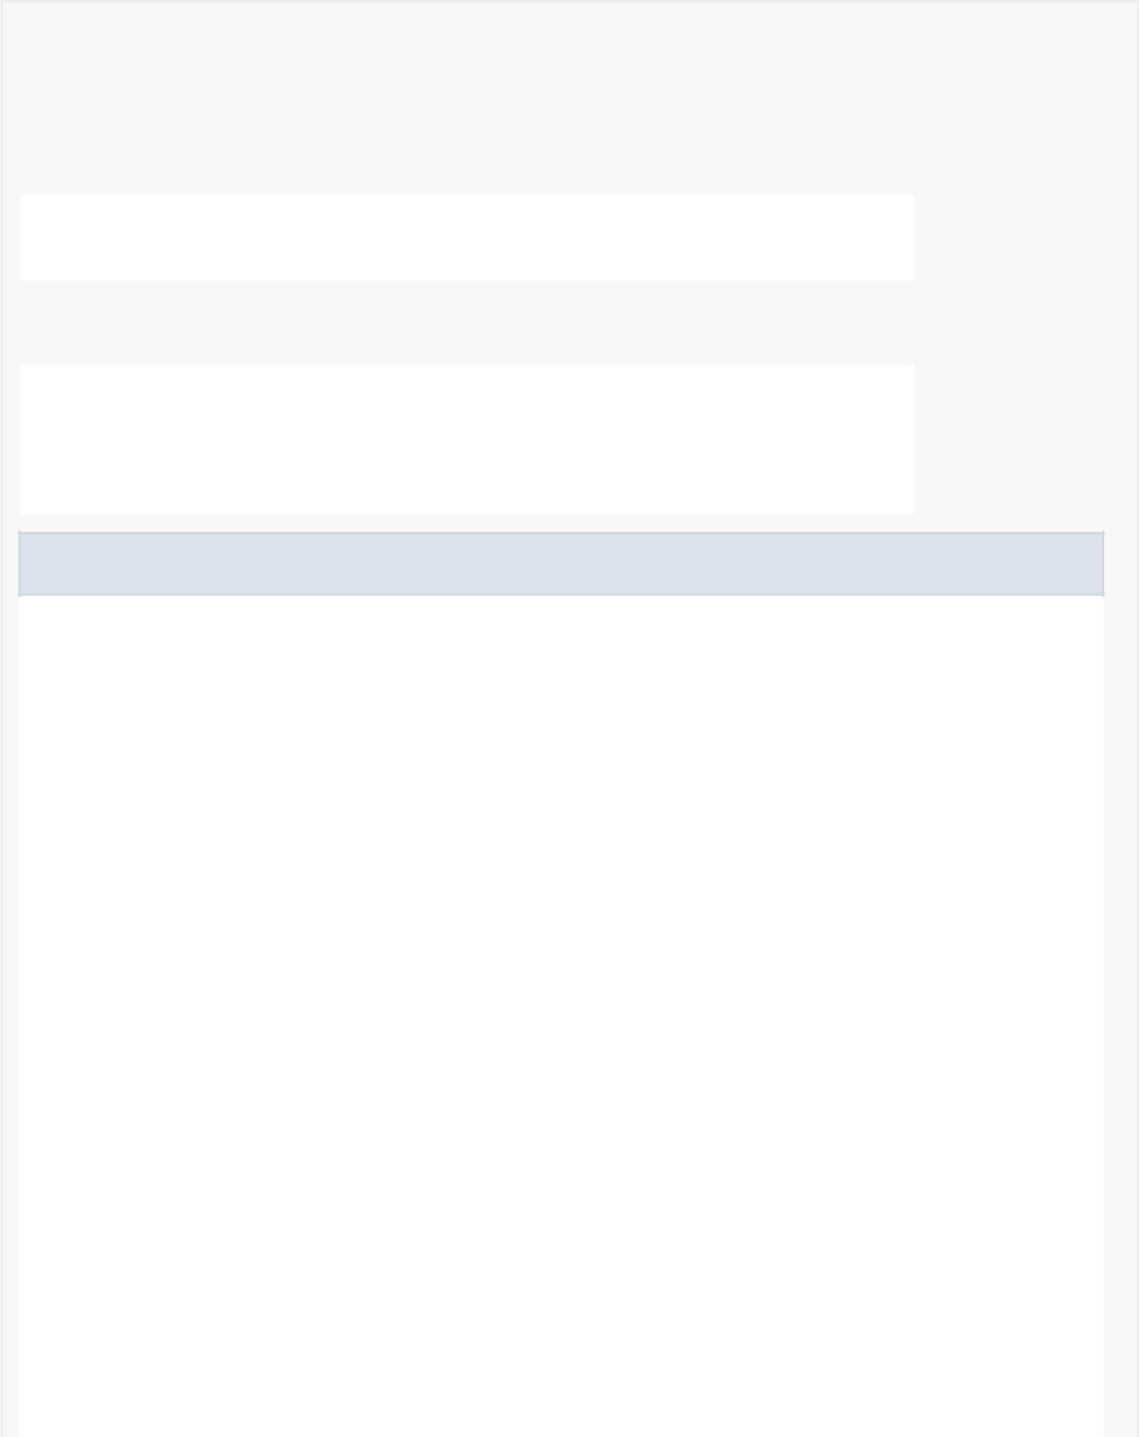

|  |  |  |  |  |  |  |  |  |
| --- | --- | --- | --- | --- | --- | --- | --- | --- |
| *Method Summary* | | | | |  |  |  |  |
|  |  | |  |  | |  |  |  |
|  | All Methods |  |  | [Instance Methods](javascript:show(2);) | |  | [Concrete Methods](javascript:show(8);) |  |
|  | Modifier and Type | | |  | Method and Description | | | |
|  | private void | | |  | addOrReplace(User user) | | | |
|  |  |  |  |  | Adds or replace a friend in the friend list. | | | |
|  |  |  |  |  |  |  |  |  |
|  | private void | | |  | loadFriends() |  |  |  |
|  |  |  |  |  | Loads the user's friends from the database. | | | |
|  | android.view.View | | | | onCreateView(android.view.LayoutInflater inflater, | | | |
|  |  |  |  |  | android.view.ViewGroup container, | | | |
|  |  |  |  |  | android.os.Bundle savedInstanceState) | | | |
|  |  |  |  |  | Creates the visual layout for fragment. | | | |
|  |  |  |  |  |  |  |  |  |

Methods inherited from class android.support.v4.app.Fragment

dump, equals, getActivity, getAllowEnterTransitionOverlap, getAllowReturnTransitionOverlap, getArguments, getChildFragmentManager, getContext, getEnterTransition, getExitTransition, getFragmentManager, getHost, getId, getLayoutInflater, getLoaderManager, getParentFragment, getReenterTransition, getResources, getRetainInstance, getReturnTransition, getSharedElementEnterTransition, getSharedElementReturnTransition, getString, getString, getTag, getTargetFragment, getTargetRequestCode, getText, getUserVisibleHint, getView, hashCode, hasOptionsMenu, instantiate, instantiate, isAdded, isDetached, isHidden, isInLayout, isMenuVisible, isRemoving, isResumed, isVisible, onActivityCreated, onActivityResult, onAttach, onAttach, onAttachFragment, onConfigurationChanged, onContextItemSelected, onCreate, onCreateAnimation, onCreateContextMenu, onCreateOptionsMenu, onDestroy, onDestroyOptionsMenu, onDestroyView, onDetach, onHiddenChanged, onInflate, onInflate, onLowMemory, onMultiWindowModeChanged, onOptionsItemSelected, onOptionsMenuClosed, onPause, onPictureInPictureModeChanged, onPrepareOptionsMenu, onRequestPermissionsResult, onResume, onSaveInstanceState, onStart, onStop, onViewCreated, onViewStateRestored, postponeEnterTransition, registerForContextMenu, requestPermissions, setAllowEnterTransitionOverlap, setAllowReturnTransitionOverlap, setArguments, setEnterSharedElementCallback, setEnterTransition, setExitSharedElementCallback, setExitTransition, setHasOptionsMenu, setInitialSavedState, setMenuVisibility, setReenterTransition, setRetainInstance, setReturnTransition, setSharedElementEnterTransition, setSharedElementReturnTransition, setTargetFragment, setUserVisibleHint, shouldShowRequestPermissionRationale, startActivity, startActivity, startActivityForResult, startActivityForResult, startIntentSenderForResult, startPostponedEnterTransition, toString, unregisterForContextMenu

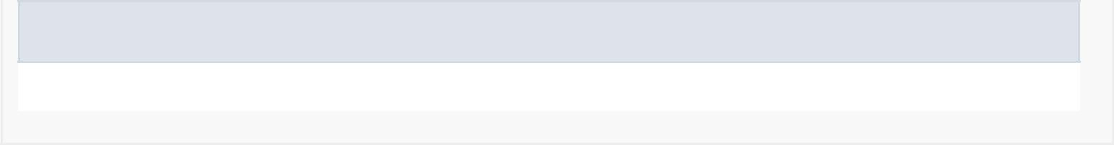Methods inherited from class java.lang.Object

clone, finalize, getClass, notify, notifyAll, wait, wait, wait



*Field Detail*

recyclerView

private android.support.v7.widget.RecyclerView recyclerView

Contains the RecyclerView from the visual layout

friends

private java.util.List<User> friends

Contains the user's friends

context

private android.content.Context context

Context from the attached activity

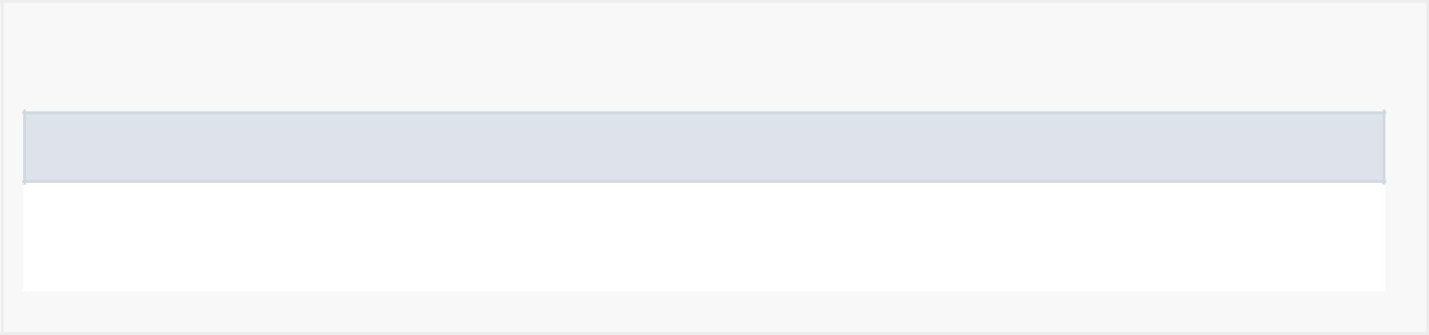

*Constructor Detail*

FriendsFragment

public FriendsFragment()

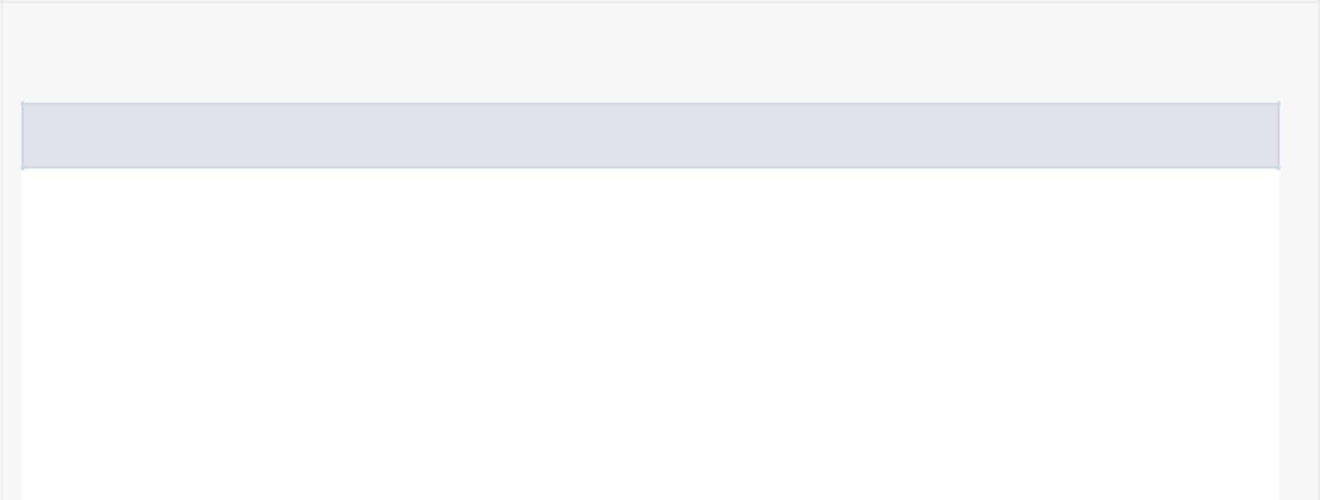

*Method Detail*

onCreateView

public android.view.View onCreateView(android.view.LayoutInflater inflater, android.view.ViewGroup container, android.os.Bundle savedInstanceState)

Creates the visual layout for fragment.

Overrides:

onCreateView in class android.support.v4.app.Fragment

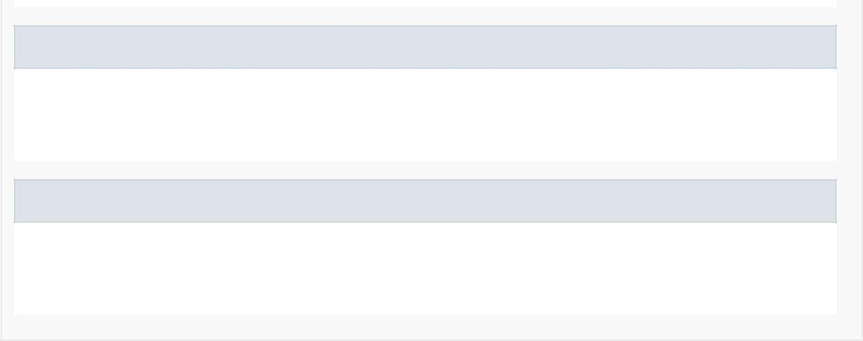addOrReplace

private void addOrReplace(User user)

Adds or replace a friend in the friend list.

loadFriends

private void loadFriends()

Loads the user's friends from the database.